**Roly Poly Toy Modelling**

**Randy Stefan TANUWIJAYA**

**Abstract:**

Roly Poly toy is a popular ancient Chinese toy which able to stabilize itself due to the low position of the center of mass. A Roly Poly can also be scaled into human size, in which it consists into a heavy hemisphecircal lower part and a handle for someone to ride it. This report models a real size Roly Poly using Runge-Kutta 4 algorithm to solve the dynamics of the objects. Animations of different configurations are provided to better illustrates the stability of the toy.

**Introduction**

Roly Poly toy is a mostly hollow, round-bottomed toy that can stabilize itself after being pushed. A weight is located at the bottom hemisphere such that any tilt will raise the center of mass. This implies that the force equilibrium occurs when the toy is standing upright, and any deviation from the equilibrium will cause the system to oscillate.

A human sized Roly Poly toy can also be made, where it can be ridden by a person. A heavy hemispherical object (~250kg) with radius of ~0.5m is located at the bottom to lower the center of mass of the system. In the following, we analyzed the 2D dynamics of simplified and complicated model of a Roly Poly toy by using Runge-Kutta 4 algorithm to solve the ODE.

**Simplified Model**

In the simplified model, we only consider the lower part of the Roly Poly toy oscillating on $xz$ plane as illustrated in Figure 1.

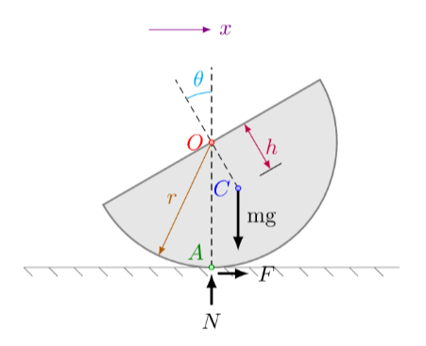

Fig 1. Lower part of Roly Poly toy

Where $O$ is the center of hemisphere, $C$ is the center of mass, $A$ is the contact point with ground, $r$ is the radius of the hemisphere, $h$ is the distance between $O$ and $C$, $mg$ is the weight force, $N$ is the normal force, F is the static friction force, $θ$ is the angle of rotation of the toy.

The Lagrangian $L$ can be defined as:

$$L=T-V= \frac{1}{2}m\left(x_{c}^{2}+y_{c}^{2}\right)+\frac{1}{2}I_{c}\dot{θ^{2}} -mgy_{c}$$

Where $I_{c}$ is the moment of inertia at $C$, $x_{c}=x+h\sin{θ}$ and $y_{c}=r-h\cos{θ}$ are the $x$ and $y$ position of $C$. The partial derivatives of $L$ with respect to $θ$ and $\dot{θ}$ are:

$$\frac{∂L}{∂θ}=mh\sin{θ}(g+{\dot{θ}}^{2}r)$$

$$\frac{d}{dt}\left(\frac{∂L}{∂\dot{θ}}\right)= \ddot{θ}\left(m\left(r^{2}+h^{2}-2hr\cos{θ}\right)+I_{c}\right) + {\dot{θ}}^{2}(m(2hr\sin{θ))}$$

Solving the Euler-Lagrange equation, we can obtain the equation of motion, which is:

$$\ddot{θ}=-\frac{{\dot{θ}}^{2}(m(2hr\sin{θ))}+mh\sin{θ}(g+{\dot{θ}}^{2}r)}{\left(m\left(r^{2}+h^{2}-2hr\cos{θ}\right)+I_{c}\right)}$$

**Complicated Model**

In complicated model, we consider that the toy consists of two part, which are: (1) the hemisphere and the lower half of the person, and (2) the upper half of the person. Moreover, we also model that the upper half of the person is leaning back and forth with the sinusoidally with amplitude of $A_{mp}$ and period of $T$, making a relative angle of $β=A_{mp}\sin\left(\frac{2π}{T}t\right)$.

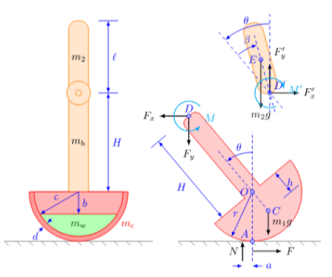

Fig 2. Illustration of Complicated Model

The Lagrangian of the system can be defined as:

$$L=\frac{1}{2}m_{1}\left({\dot{x_{1}}}^{2}+{\dot{y_{1}}}^{2}\right)+\frac{1}{2}m_{2}\left({\dot{x_{2}}}^{2}+{\dot{y_{2}}}^{2}\right)+\frac{1}{2}I_{1}{\dot{θ_{1}}}^{2}+\frac{1}{2}I_{2}{\dot{θ_{2}}}^{2}-m_{1}gy_{1}-m_{2}gy_{2}$$

Where $m_{1}$, $m_{2}$, $I_{1}$, $I_{2}$ are the mass and moment of inertia of the lower and upper part, $x_{1}$, $y_{1}$, $x_{2}$, $y_{2}$ are the $x$ and $y$ position of the center of mass of lower and upper part, $θ_{1}$, $θ_{2}$ are the angle of rotation for lower and upper part measured counter clockwise.

The partial derivatives of $L$ with respect to $θ$ and $\dot{θ}$ are:

$$\frac{∂L}{∂θ}=\left(g+{\dot{θ}}^{2}r\right)\left(m_{1}\left(h\sin{θ}\right)-m_{2}\left(H\sin{θ}+\frac{l}{2}\sin\left(θ+β\right)\right)\right)-\left(\dot{θ}\dot{β}r\right)\left(m_{2}\left(\frac{l}{2}\sin\left(θ+β\right)\right)\right)$$

$$\frac{d}{dt}\left(\frac{∂L}{∂\dot{θ}}\right)= \ddot{θ}\left(m_{1}\left(r^{2}+h^{2}-2rh\cos{θ}\right)+I_{1}+m_{2}\left(r^{2}+H^{2}+{\frac{l}{4}}^{2}+2rH\cos{θ+2r\frac{l}{2}}\cos\left(θ+β\right)+2H\frac{l}{2}\cos{β}\right)+I_{2}\right)+{\ddot{β}}^{2}\left(m_{2}\left(r\frac{l}{2}\cos\left(θ+β\right)+H\frac{l}{2}\cos{β}+\frac{l^{2}}{4}\right) I_{2}\right)+{\dot{θ}}^{2}\left(m_{1}\left(2rh\sin{θ}\right)+m_{2}\left(-2rH\sin{θ}-2r\frac{l}{2}\sin{θ}\right)\right)+{\dot{β}}^{2}\left(m_{2}\left(-r\frac{l}{2}\sin\left(θ+β\right)\right)-H\frac{l}{2}\sin{β}\right)+\dot{θ}\dot{β}\left(m_{2}\left(-2r\frac{l}{2}\sin\left(θ+β\right)-2H\frac{l}{2}\sin{β}-2r\frac{l}{2}\sin{(θ+β)}\right)\right)$$

The equation of motion can be obtained by solving the Euler-Lagrange equation

$$\frac{∂L}{∂θ}-\frac{d}{dt}\left(\frac{∂L}{∂\dot{θ}}\right)=0$$

**Implementation**

For the simple model, we initialize the variables as the following: $r=0.5m$, $h=\frac{3}{8}r$, $I_{c}=\frac{83}{320}m$, $m=250kg$. Using Runge-Kutta 4 algorithm, we solve for the angle $θ(t)$, angular velocity $\dot{θ}(t)$, and the height of the center of mass $h_{c}\left(t\right)$ for $θ\left(0\right)=60°$ and $\dot{θ}\left(0 \right)=0$ as a function of $t$ and plot it to the following figures for $t=[0,10]$. The animation are submitted separately under “RolyPoly_simplified.mp4”.

Fig 3. Plot of simplified model

For the complicated model, we initialize the variables as the following: $r=0.5m$, $h=\frac{3}{8}r$, $l=0.73m$, $H=0.9m$, $m_{1}=275kg$, $m_{2}=20kg$, $I_{1}=28.34kg.m^{2}$, $I_{2}=0.94kg.m^{2}$. Using Runge-Kutta 4 algorithm, we solve for the angle of lower part $θ\left(t\right)$, relative angle of lower and upper part $β\left(t\right)$, the horizontal and vertical force of upper part to lower part $F_{x}\left(t\right)$ and $F_{y}\left(t\right)$. The first configuration is when there is no relative angle of upper part and lower part $A_{mp}=0$, $θ\left(0\right)=30°$, $\dot{θ}\left(0\right)=0$. The second configuration is when the person is moving, $A_{mp}=30°$, $T=2.18s$, $θ\left(0\right)=0$, $\dot{θ}\left(0\right)=0$. Then we plot for both configurations for $t=\left[0,10\right]$. Animations are submitted separately under “RolyPoly_complicated1.mp4” and “RolyPoly_complicated2.mp4”.

Fig 4. Plot of the first configuration of complicated model

Fig 5. Plot of the second configuration of complicated model